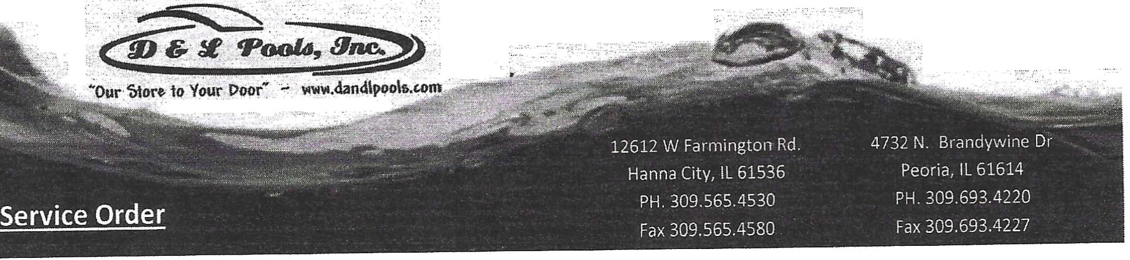

Name: ______________________________ ^{Date: ____________________}

Address: ____________________________

Phone: Text Ok:

Description of Work Employee

We do NOT do electrical or HVAC work.

All material is guaranteed to be as specified. All work to be completed in a neat and workman like manner according to standard practices. Any alteration or deviation from above specifications involving extra costs for material or labor will be executed only upon written orders and a signed change order and will become an extra charge over and above the estimate. All agreements are contingent upon accidents or delays beyond our control. Our workers are fully covered by Workman's Compensation Insurance.
D & L Pools. Inc is not responsible and shall be held harmless for non-apparent ground conditions, extrusions and liner track conditions. Any floor or wall repairs needed once existing liner is removed will be charged as an extra and not included in above price. D & L Pools. Inc. is not responsible and shall be held harmless due to any caving. moving and/or shifting of pool walls and components thereof.
D & L Pools, Inc is not responsible for Acts of God or unavoidable delays.

Service Order Acceptance - The above service specifications., and conditions are satisfactory and are hereby accepted. You are authorized to do the work as specified . Payment will be due upon receipt of invoice. The undersigned hereby agrees that in the event legal action is instituted to enforce payment of the amount due pursuant to such extension of credit, the undersigned shall be liable for all attorney's fees, costs and expenses of collection which are typically 33% to 50%, as well as legal interest from the date the original amount was due. The undersigned further agrees that notwithstanding the fact that this Credit Application and Representations have been executed in a corporate or representative capacity, each signer hereof by such signature, hereby are personally and individually responsible for payment to D & L Pools, Inc. Of all amounts due pursuant to such extension of credit, according to invoice amount and credit terms stated thereon. The undersigned further represents that there are not unpaid judgments, or open accounts more than ninety days past due, outstanding against the undersigned .
Signature: _ Date of Acceptance: _
Note: Please remit deposit and signed proposal to the Hanna City location: P. 0. Box 80 Hanna City, IL 61536 (309) 565-4530

